Functional Assessment
Observation Tools

- ABC Observation Form (Pg 1-4)
- Functional Assessment Scatterplot (Pg 5-7)
- Classroom Scatterplot (Pg 8-9)
- Functional Assessment Observation Form (Pg 10-12)
- PA Data Collection Tools (Pg 13-26)

ABC OBSERVATION FORM

Student Name: _______________ |  | Observation Date:________
Observer: __________________ |  | Time: _________________
Activity: ___________________ |  | Class Period: ____________
ANTECEDENT | BEHAVIOR | CONSEQUENCE

ABC OBSERVATION FORM

Student: _____________________ Observer: ______________________
Date: ______________ Time: ___________ Activity: _______________

_______________________________________________________________
Context of Incident:

Antecedent:

Behavior:

Consequence:

Comments/Other Observations:

ABC OBSERVATION FORM

Student Name: Ben S. |  | Observation Date: 10/5
Observer: R. Day |  | Time: 9:40-9:55 a.m.
Activity: disruptive behavior |  | Class Period: 3
ANTECEDENT | BEHAVIOR | CONSEQUENCE
Teacher begins – tells students to look at board. | Ben looks around the room and at other kids. | Teacher continues lesson; ignores Ben.
Teacher puts examples on board and asks class to work problems. | Ben looks around and calls to Fran. | Teacher asks for quiet.
Teacher tells class to do 5 more problems. | Ben turns around and pokes Fran with pencil. | Teacher tells Ben, “get to work, NOW!”
 | Ben calls out, “this is too hard.” He throws worksheet and book on floor. | Teacher demands that Ben come forward, get a hall pass, and go to the office.

ABC OBSERVATION FORM

Student Name: Trish_______ |  | Observation Date: 10/5__
Observer: Ms. Pasillas___ |  | Time: 9:40-9:55 a.m.____
Activity: disruptive behavior on the playground |  | Class Period: 3_________
ANTECEDENT | BEHAVIOR | CONSEQUENCE

Trish joins group of 4 girls playing catch.
 | Trish waits for ball to be thrown to her.
 |  | Girls do not throw ball to Trish.
 | Trish yells “Throw it to me!”

Girls throw ball to her, she

misses it and another girl,

LuAnne catches it and throws

it to Sandy.
Ball is again thrown to Karen. | Trish yells “ I said throw it to me you jerk!”
Karen begins to walk away with the ball. | Trish runs up behind Karen and kicks her saying “Give it to me damn it!” | Karen cries. Trish takes  the ball.

FUNCTIONAL ASSESSMENT SCATTERPLOT

Student: _______________________________ Grade: ________ School: ______________________________

Date(s): _______________________________ Observer(s):_________________________________________

Behavior(s) of concern: ________________________________________________________________________

ACTIVITY | TIME |  |  | DAY OF THE WEEK |  |  | TOTAL
 |  | Monday | Tuesday | Wednesday | Thursday | Friday

TOTAL

FUNCTIONAL ASSESSMENT SCATTERPLOT

Student: Myree Grade: 6th School: John B. Lynn

Date(s): 10/4/97 to 10/8/97 Observer(s): Dennis

Behavior(s) of concern: disrupts class w/inappropriate comments and verbal threats directed at peers.

Setting: __________________________________________________________________________________

ACTIVITY | TIME |  |  | DAY OF THE WEEK |  |  | TOTAL
 |  | Monday | Tuesday | Wednesday | Thursday | Friday

TOTAL

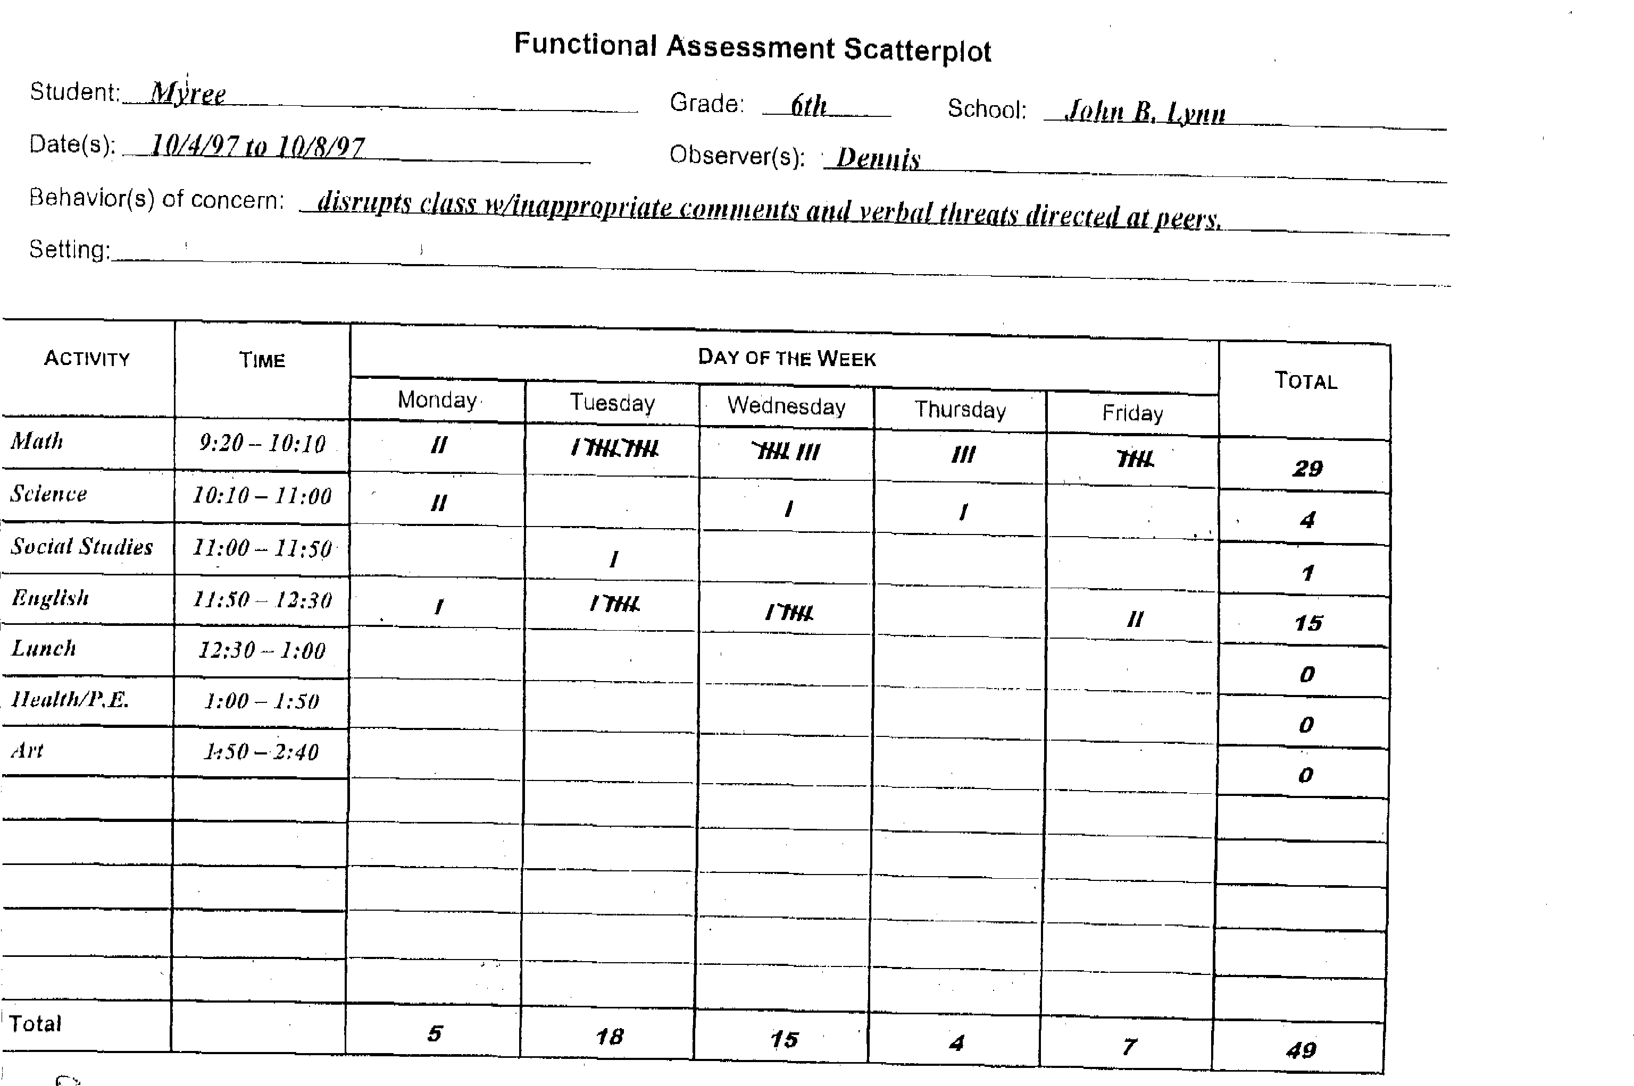

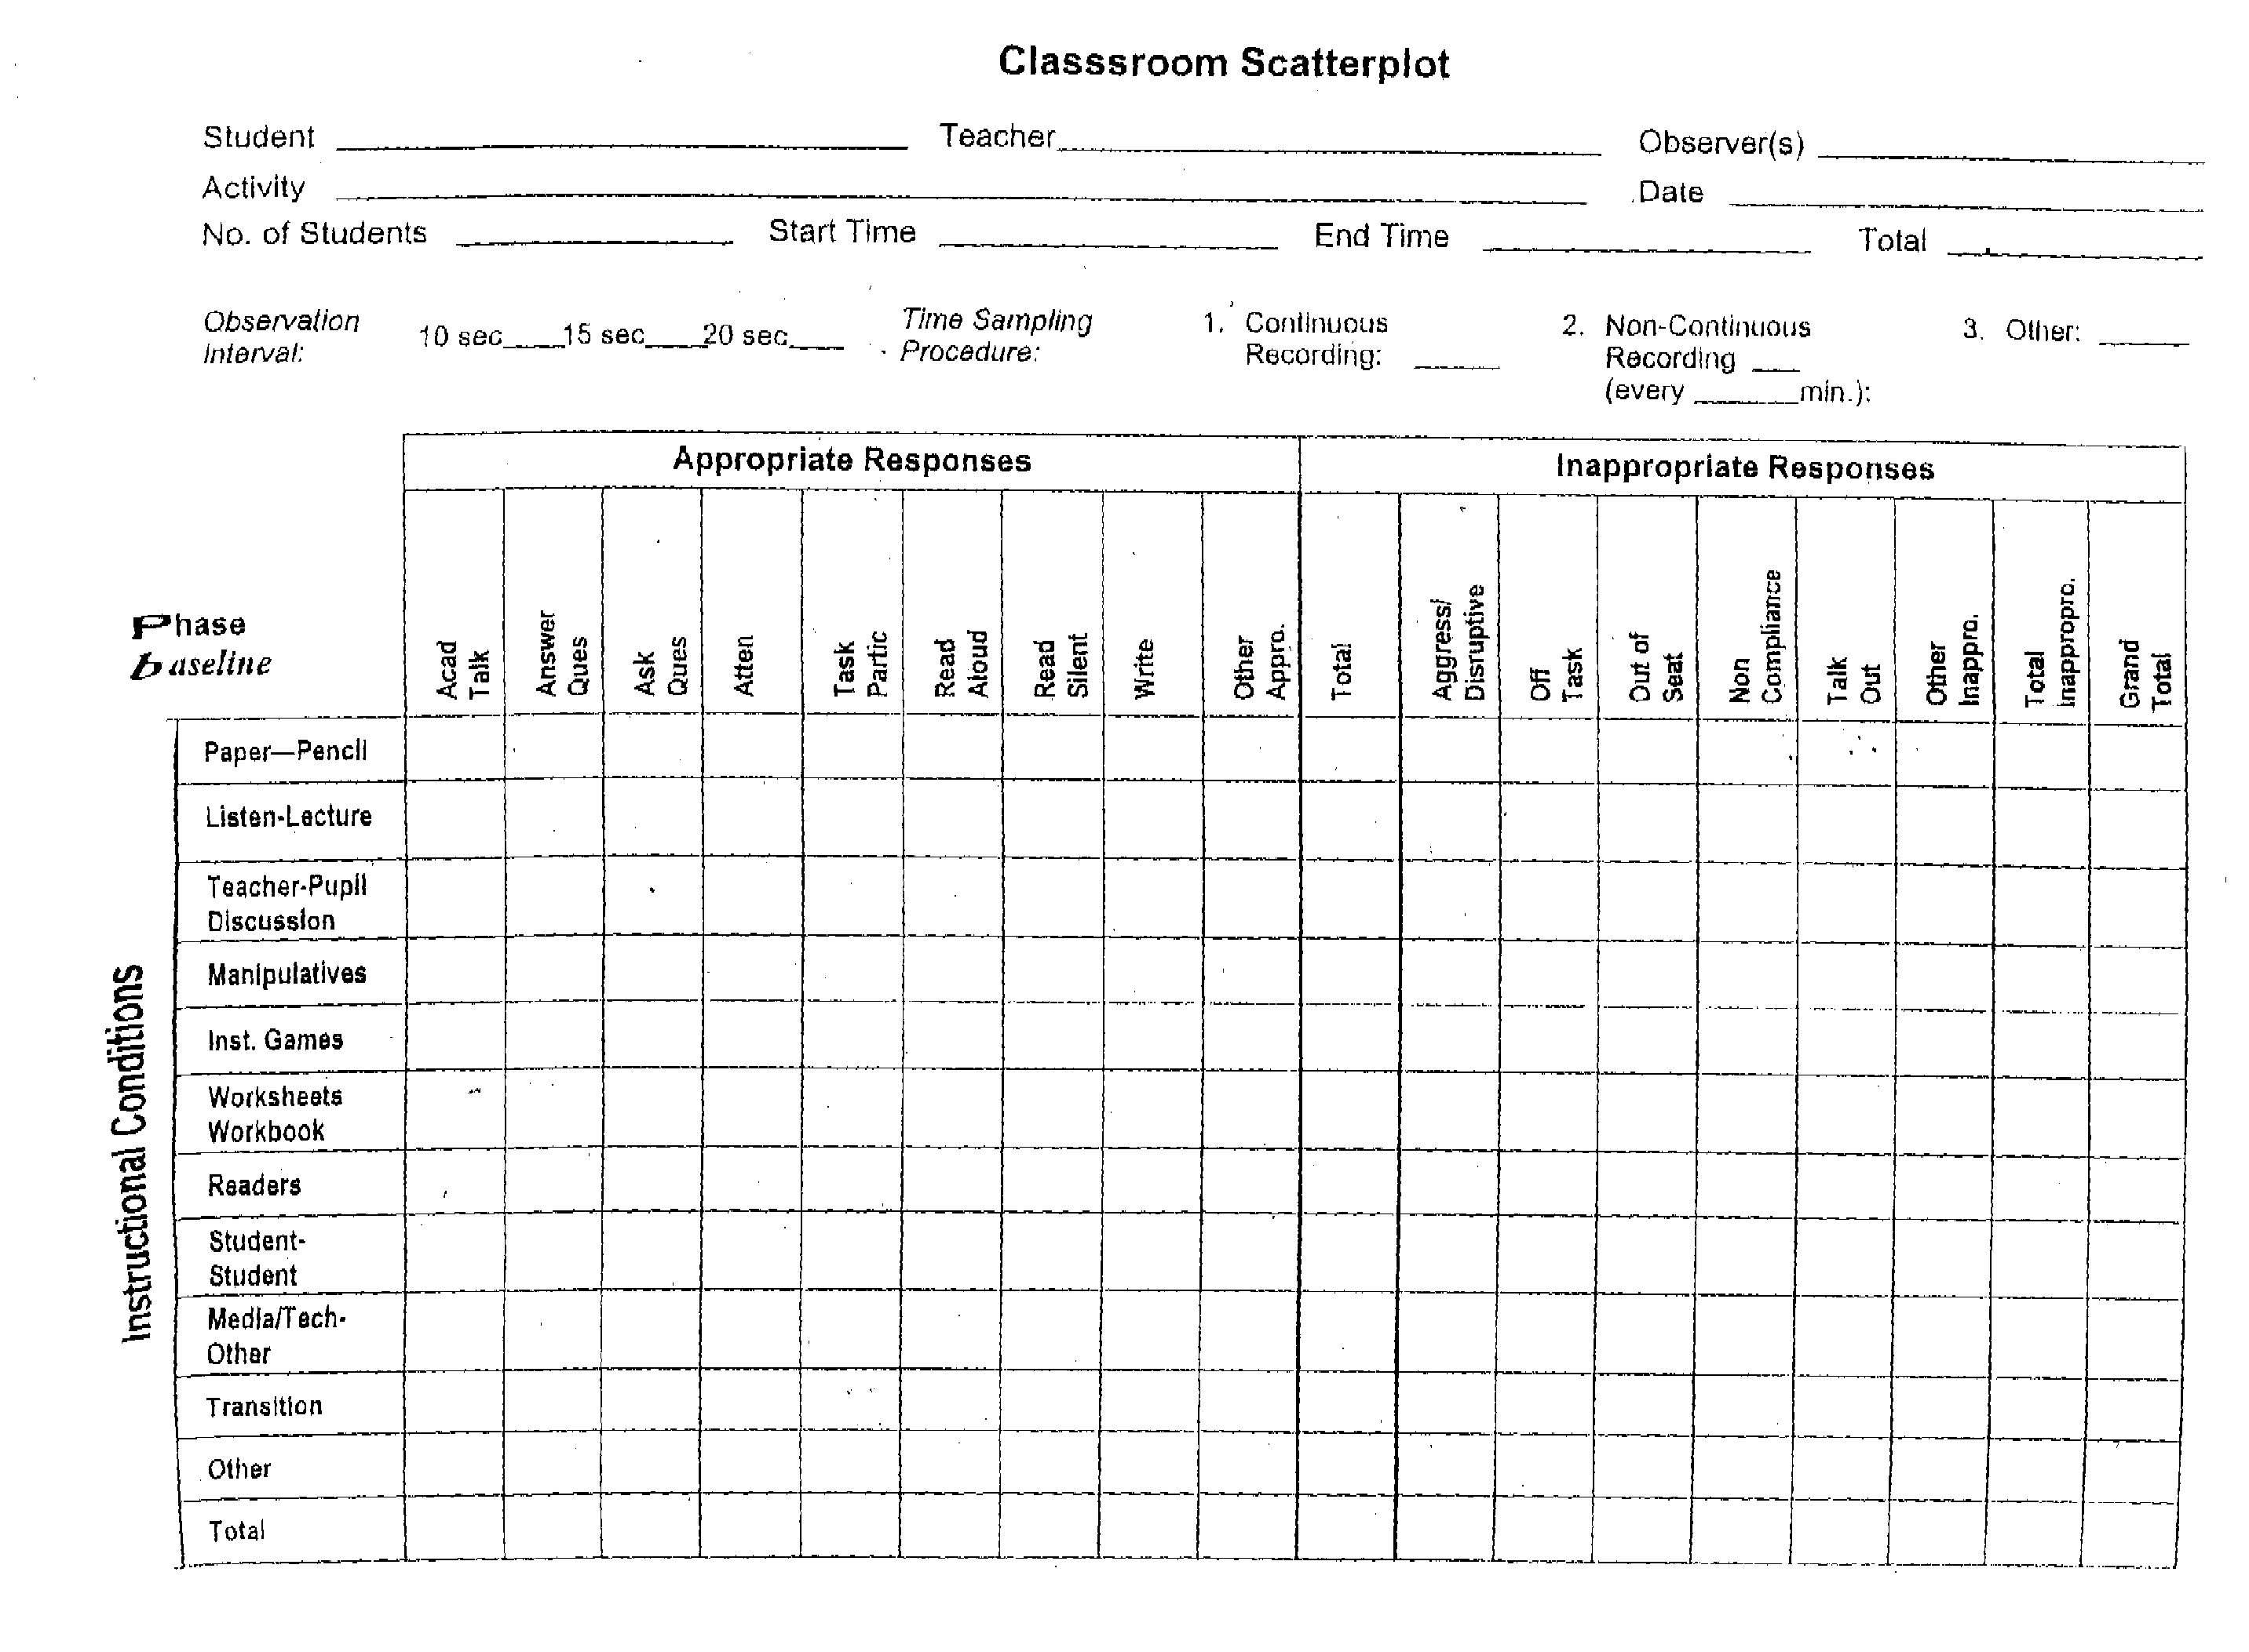

Classroom Scatterplot

Student Charles Teacher Miller Observer(s) Evans

Activity Date

No. of Students 21 Start Time 9:10 End Time 9:55 Total 45 min

Observation Time Sampling 1.Continuous 2.Non-Continuous 3. Other
Interval: 10 sec 15 sec 20 sec X Procedure: Recording: Recording X
(every 3 min.)

 |  | Appropriate Responses |  |  |  |  |  |  |  |  | Inappropriate Responses
Phase  baseline |  | Talk Acad | Answer Ques | Ask Ques | Atten | Task Part | Read Aloud | Read Silent | Write | Other Appro | Total | Aggress/ Disruptive | Off Task | Out of Seat | Non-compliance | Talk Out | Other Inappro | Total Inaappro | Grand Total
Instructional Conditions | Paper-Pencil
Instructional Conditions | Listen-Lecture |  |  | I |  |  |  |  |  |  | 1 |  |  |  |  |  |  |  | 1
Instructional Conditions | Teacher-Pupil  Discussion |  | II |  | II |  |  |  |  |  | 4 | I |  |  |  | II |  | 3 | 7
Instructional Conditions | Manipulatives
Instructional Conditions | Inst. Games
Instructional Conditions | Worksheets  Workbook
Instructional Conditions | Readers |  |  |  |  |  |  |  |  |  |  | III | II |  | II | IIII | II | 14 | 14
Instructional Conditions | Student-Student
Instructional Conditions | Media/Tech-  Other
Instructional Conditions | Transition
Instructional Conditions | Other
Instructional Conditions | Total | 0 |  | 1 | 2 | 0 | 0 | 0 | 0 |  | 5 | 4 | 2 | 0 | 2 | 7 | 2 | 17 | 22

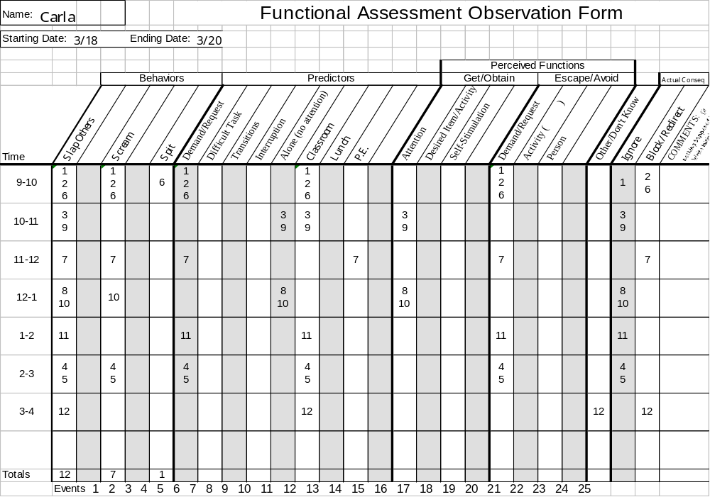
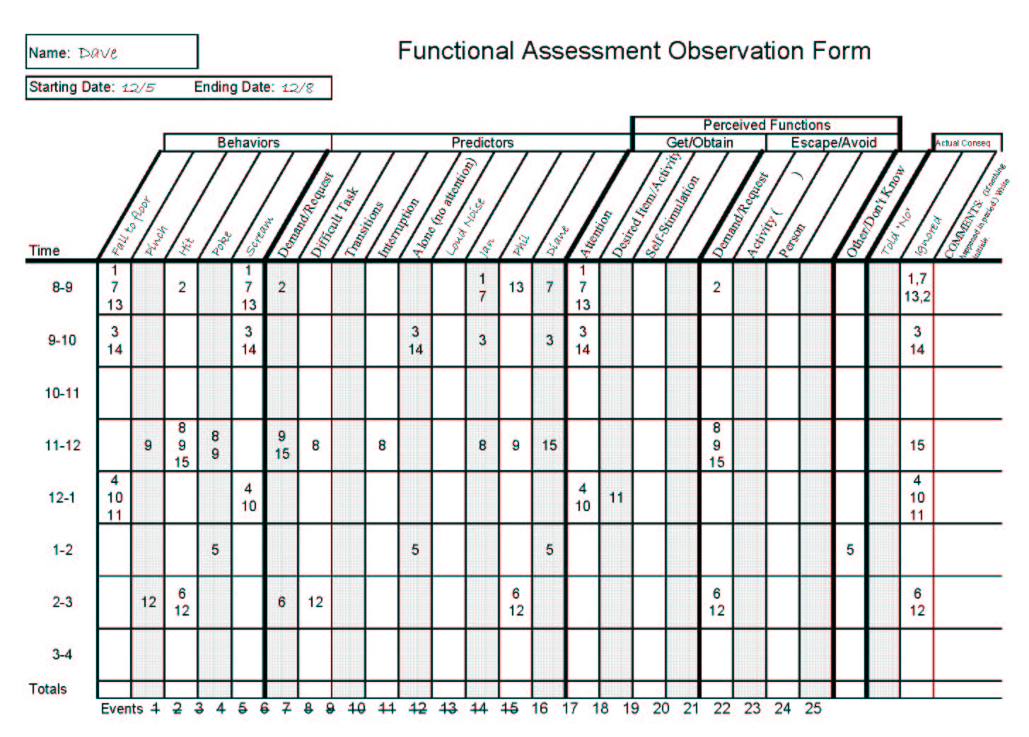

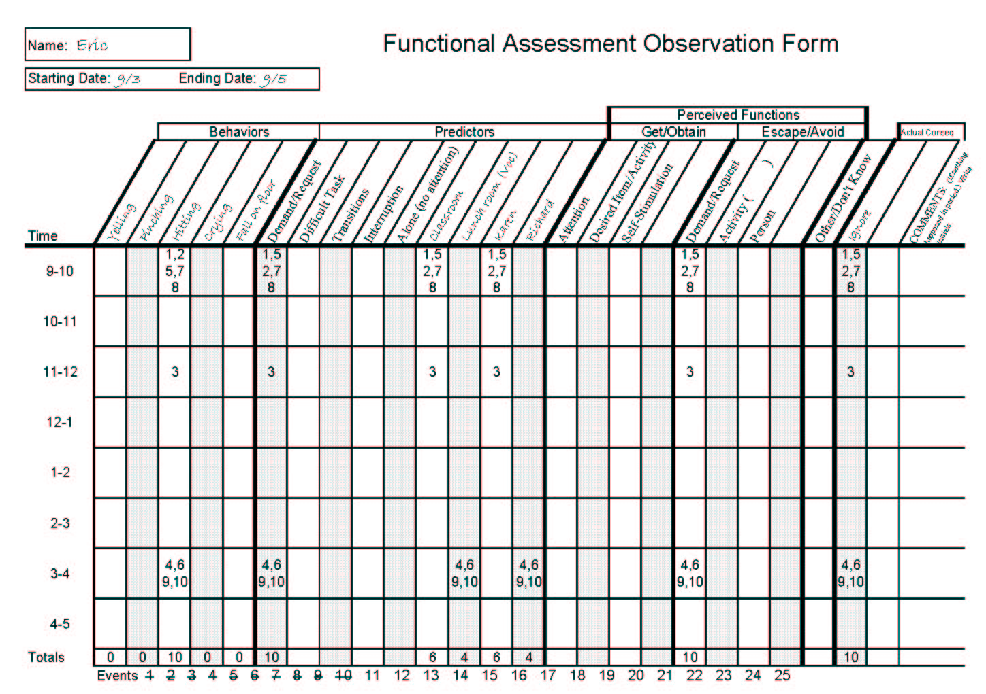

ABC Chart

Student: Date: Observer:

Setting Event(s):
Antecedent | Behavior | Consequence

ABC Chart

Student: Date: Observer:

Setting Event(s):
Antecedent | Behavior | Consequence

Basic Event Recording: To collect data on the frequency of a targeted behavior. Define a date and time period to collect data and record a tally each time the behavior is observed in that time frame.

Student: ______________________________________________________

Observer: __________________________________________________________________________________________

Behavior: __________________________________________________________________________________________
__________________________________________________________________________________________________

Date | Time | Tally | Total

Basic Event Recording: To collect data on the frequency of a targeted behavior. Define a date and time period to collect data and record a tally each time the behavior is observed in that time frame.

Date | Time | Tally | Total
January 5th | 8:00 – 9:00  9:00 – 10:00  10:00 – 11:00  11:00 – 12:00  12:00 – 1:00  1:00 – 2:00  2:00 – 3:00 | | | |  | | | | | | |  | | | | | | | | | |  | |  | | | | | | | | | | | |  | | | | | | | | | | | |  | | | | | | | | | | | | | | | 3  7  10  2  12  12  14
Student: Patty O’Fernicher

Observer: Ms. Smith

Behavior: Talking out in class without raising her han
Basic Event Recording: To collect data on the frequency of a targeted behavior. Define a date and time period to collect data and record a tally each time the behavior is observed in that time frame.

Student Sandy Beach

Observer Mr. Jones

Behavior Completing and returning homework assignments

Date Homework Assigned | Number of Assignments | Number Returned | Comments / Notes
January 20th  January 21st  January 22nd  January 23rd  January 27th  January 28th  January 29th | 3  2  2  2  4  2  2 | 2  0  0  1  1  2  1 | Said she didn’t know about the other assignments  Couldn’t find them  Said she left them at home  Said, “I don’t care” about homework  Earned 5 minutes on computer

Behavior Card: To collect data on antecedents, behaviors of concern, and consequence strategies utilized.

Student: | Activity: | Date: | Time:
Antecedent(s):  - Asked to do something  - Attention given to others  - Ongoing behavior interrupted  - Bored-no materials/activities  - Could not get desired item  - Appeared to be in discomfort  - Loud/disruptive environment  - Other student provoked  - Other | Behavior of Concern:  - Off-task  - Noncompliance  - Running away  - Physical/verbal aggression  - Playing with objects  - Screaming/tantruming  - Self injurious behavior  - Fidgeting  - Provoking/Teasing others  - Other | Consequence(s):  - Verbal redirection to activity  - Physical redirection to activity  - Required to continue activity  - Ignoring  - Time out (duration )  - Within room area  - Outside room area  - Physical discomfort relieved  - Interruption/blocking  - Physical restraint  - Other

Duration Recording: To collect data on the length of time the student engages in a particular behavior.

Student: Behavior:

Observer:

Date | Time of Behavior Initiation | Time of Behavior Completion | Duration

Duration Recording: To collect data on the length of time the student engages in a particular behavior.

Student: Phil R. Yuppe Behavior: Sleeping with head down on desk

Observer: John Smith (Algebra Teacher)

Date | Time of Behavior Initiation | Time of Behavior Completion | Duration
March 3rd | 9:05 | 9:25 | 20 minutes
March 4th | 9:07 | 9:22 | 15 minutes
March 5th | 9:11 | 9:40 | 28 minutes
March 6th | 9:10 | 9:18 | 8 minutes
March 7th | 9:05 | 9:24 | 19 minutes

Event Recording: for controlled presentations when the teacher structures the number of opportunities the student will have to perform the behavior:

Name

Task

Date

10 10 10 10
9 9 9 9
8 8 8 8
7 7 7 7
6 6 6 6
5 5 5 5
4 4 4 4
3 3 3 3
2 2 2 2
1 1 1 1

Comments

Interval Recording & Time Sampling

Student: Behavior:

Date/Time:

Observer:

Time & Date
Latency Recording: To collect data on the time between when a cue is given and student initiation of the behavior.

Student: Behavior:

Observer:

Date | Time of Cue | Time of Initiation of Behavior | Latency

Latency Recording: To collect data on the time between when a cue is given and student initiation of the behavior.

Student: Phineas Gage Behavior: Take seat upon direction from teacher

Observer: John Harlow

Date | Time of Cue | Time of Initiation of Behavior | Latency
September 13th | 8:07 | 8:13 | 6 minutes
 | 8:19 | 8:20 | 1 minute
 | 9:25 | 9:27 | 2 minutes
 | 10:37 | 10:44 | 7 minutes
 | 1:35 | 1:40 | 5 minutes
Anecdotal Record: To collect descriptive, or topographic, information about a particular behavior of concern.

Name: Grade: Teacher:

Date | Incident | Comment
Anecdotal Record: To collect descriptive, or topographic, information about a particular behavior of concern.

Name: Albert B. Grade: Pre-school Teacher: J. Watson

Date | Incident | Comment
6/14  6/17 | Albert was seated on the floor playing with blocks. He was smiling and babbling as he played. When presented with a soft, white stuffed toy rat, Albert attempted to play with it. I then hit a steel bar with a hammer to elicit a startle response. Albert started violently, his breathing was checked, and his arms were raised in a characteristic manner.  Albert was, again, sitting on the floor happily playing with toys. This time when I presented the white rat in the absence of the loud noise, he broke into a sudden crying fit. | In an effort to condition Albert, I have presented the neutral stimulus (white rat) with the unconditioned stimulus (loud sound).  I have successfully conditioned a startle response in Albert to the white rat.

