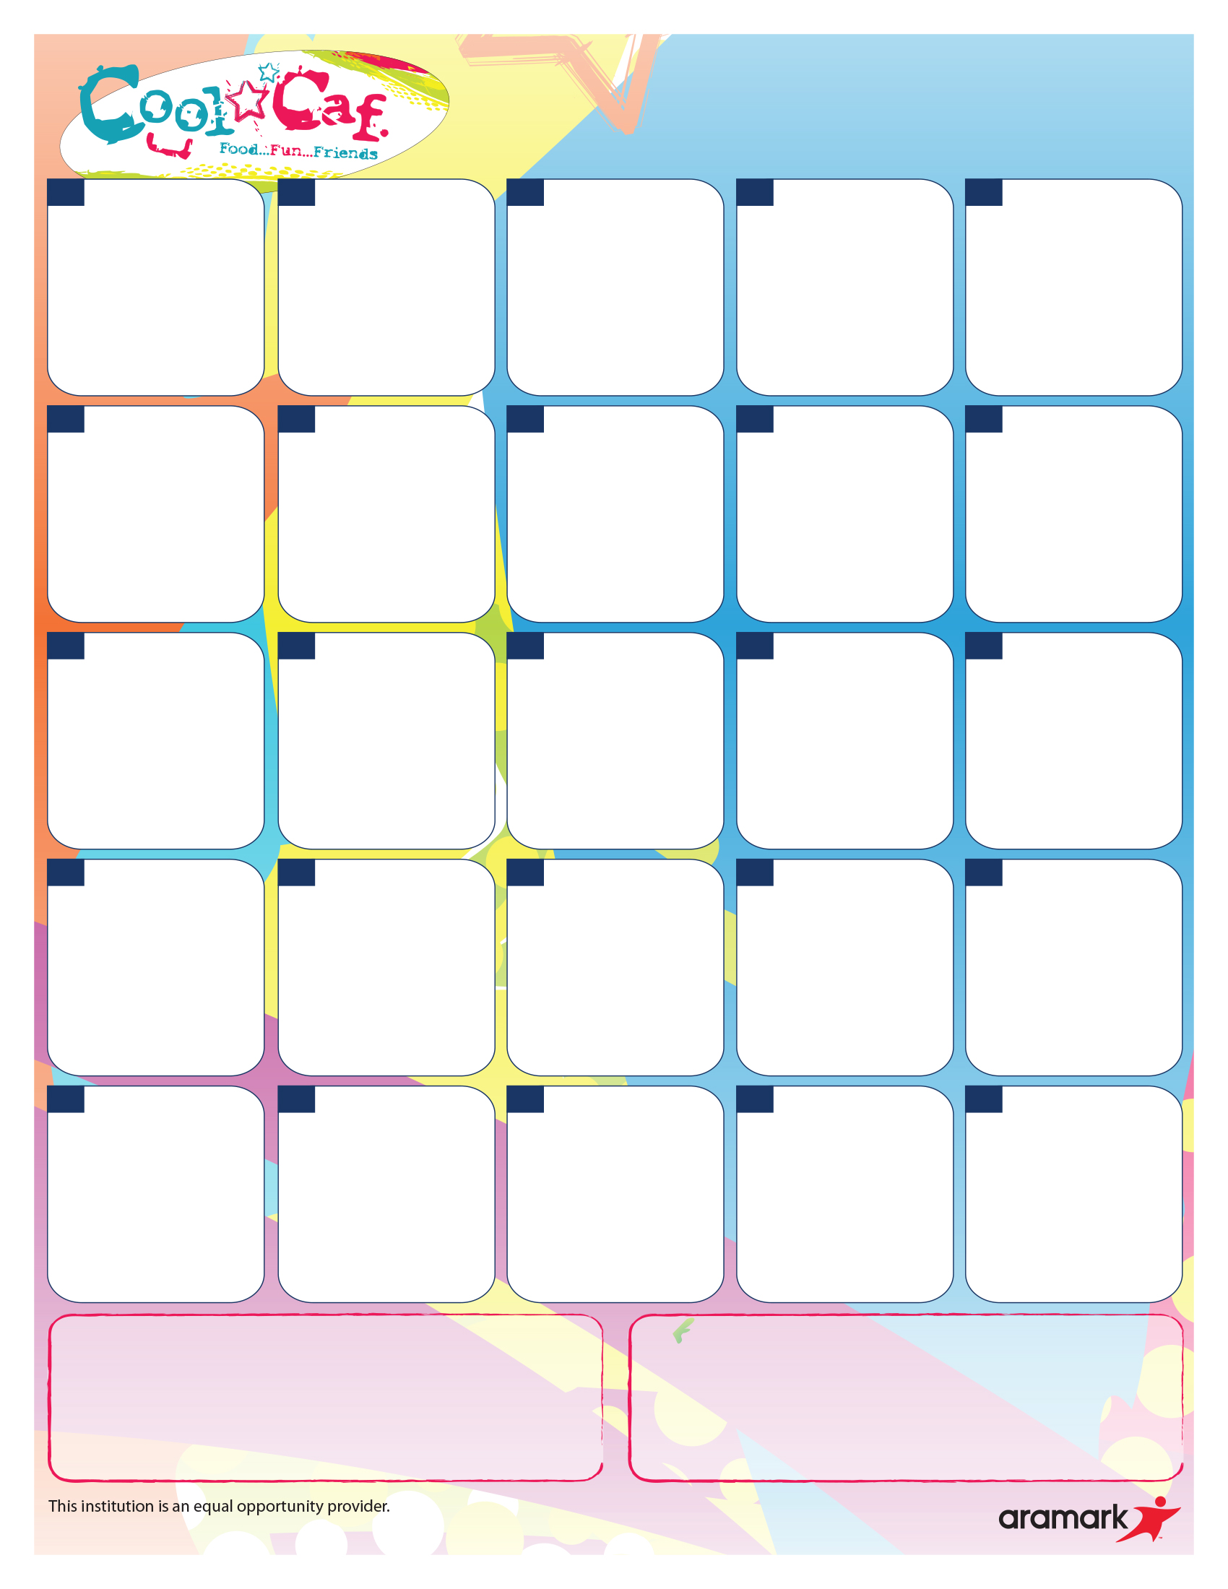

Breaded Chicken Boneless Wings

OR

Italian Style Sub

--------------Side Items--------------

Smiley Fries

Seasonal Fresh Fruit

Italian Dunkers & Marinara Sauce*V

OR

Oven Roasted Turkey &

Cheese Sub

-------------Side Items-------------

Sliced Carrots

Seasonal Fresh Fruit

Grilled Chicken Ranch Club Oven-Fired Flatbread

OR

Breaded Chicken and Cheese Snack Wraps

------------Side Items-----------

Spinach Salad with Oranges

Seasonal Fresh Fruit

Pizza Hut Cheese Pizza*V

OR

Hummus & Veggie Plate with Oven-Fired Flatbread*V

------------Side Items------------

Tater Tots

Seasonal Fresh Fruit

100% Ground Beef Nachos*SC

OR

Grilled Chicken Baja Salad

--------------Side Items--------------

Pinto Beans

Seasonal Fresh Fruit

Honey Ham & Cheese Melt

OR

Oven-Fired Flatbread Pizza Kit*V

--------------Side Items--------------

Green Peas & Carrots

Seasonal Fresh Fruit

**NO SCHOOL**

**NO SCHOOL**

Waffles & Turkey

Sausage Links

OR

Grilled Chicken, Feta Cheese,

and Berry Salad

--------------Side Items--------------

Smiley Fries

Seasonal Fresh Fruit

Cheddar Cheese Oven-Fired Flatbread Melt*V

OR

Oven Roasted Turkey &

Cheese Sub

--------------Side Items--------------

Sweet Corn

Seasonal Fresh Fruit

Crispy Chicken Breast Sandwich

OR

Grilled Chicken Taco Salad

--------------Side Items--------------

Black Beans

Seasonal Fresh Fruit

Italian Cheesy Pull-Apart*V

OR

Honey Ham & Cheese Oven-Fired Flatbread Kit

------------Side Items------------

Green Beans

Seasonal Fresh Fruit

Cheese Quesadilla*V

OR

Grilled Chicken Caesar Salad

with Roll

------------Side Items-----------

Garden Salad

Seasonal Fresh Fruit

Crispy Chicken Breast Sandwich

OR

Grilled Chicken, Feta Cheese

and Berry Salad

--------------Side Items--------------

Tater Tots

Seasonal Fresh Fruit

American Grilled Cheese*V

OR

Oven Roasted Turkey & Cheese Sub

--------------Side Items--------------

Sliced Carrots

Seasonal Fresh Fruit

Golden Crispy Chicken Nuggets with Breadstick

OR

Grilled Chicken Caesar Salad

with Roll

------------Side Items------------

Spinach Salad with Oranges

Seasonal Fresh Fruit

100% Beef Cheeseburger

OR

Honey Ham & Cheese Oven-Fired Flatbread Kit

------------Side Items-----------

Baked Beans

Seasonal Fresh Fruit

100% Beef Hot Dog

OR

Grilled Chicken Taco Salad

--------------Side Items--------------

Green Peas

Seasonal Fresh Fruit

100% Beef Meatballs over Penne Pasta*SC

OR

Oven-Fired Flatbread Pizza Kit*V

--------------Side Items--------------

Green Peas & Carrots

Seasonal Fresh Fruit

Grilled Chicken

Soft Tacos*SC

OR

Grilled Chicken Taco Salad

--------------Side Items--------------

Black Beans

Seasonal Fresh Fruit

**NO SCHOOL**

**NO SCHOOL**

**24**

**\*SC – Made from scratch *V - Vegetarian**

**Breakfast Price: $2.50**

**Lunch Price: $4.00**

**Cold Vegetable Choices May Include:**

Monday: Baby Carrots/Broccoli Florets

Tuesday: Broccoli Florets/ Red Pepper Strips

Wednesday: Baby Carrots/ Cucumbers

Thursday: Celery Sticks/ Grape Tomatoes

Friday: Baby Carrots/ Cucumbers

All chicken products offered are Tyson chicken raised with no antibiotics ever. No added hormones or steroids. No artificial ingredients. Whole grain breading.

All deli meats offered are Smithfield Healthy Ones. No MSG or added hormones. No artificial flavors.

**Offered Daily with Breakfast Meal: Offered Daily with Lunch Meal:**

Entrée, Fruit and Milk Entrée, Fruit, Vegetable and Milk

**28**

**18**

**9**

**17**

**10**

**8**

**25**

**23**

**1**

**4**

**3**

**21**

**16**

**15**

**14**

**7**

**11**

**\*Gluten-Free meals available upon request.**

**For more detailed nutritional information, please visit: ptsdk12pa.nutrislice.com/menu**

**2**

**30**

**29**

**22**

**IU Lunch**

**November 2022**