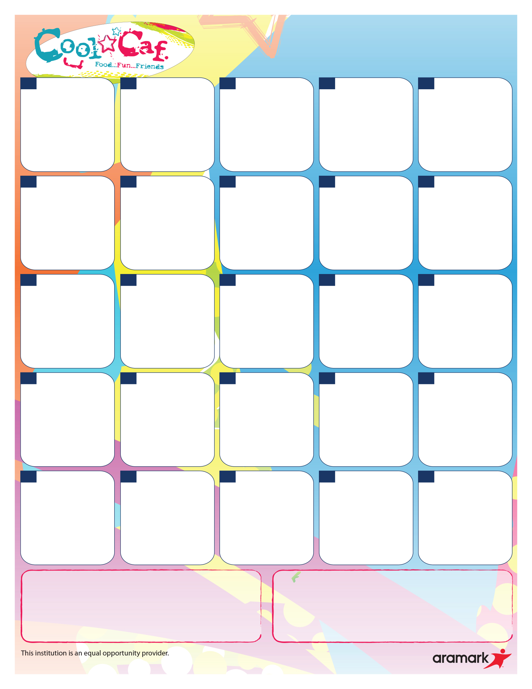

Pillsbury Cinni Mini’s

--------------Side Items------------

Milk

Seasonal Fresh Fruit

French Toast Benefit Bar

-------------Side Items-------------

Milk

Juice

Cereal with String Cheese

--------------Side Items--------------

Milk

Seasonal Fresh Fruit

Chocolate Crescent

--------------Side Items--------------

Milk

Juice

Maple Mini Waffles

--------------Side Items--------------

Milk

Juice

Banana Chocolate Benefit Bar

--------------Side Items--------------

Milk

Seasonal Fresh Fruit

Cinnamon Pop Tart and Yogurt

--------------Side Items--------------

Milk

Seasonal Fresh Fruit

Apple Frudel

-------------Side Items------------

Milk

Juice

Cereal with String Cheese

------------Side Items----------

Milk

Seasonal Fresh Fruit

Cereal with String Cheese

--------------Side Items--------------

Milk

Seasonal Fresh Fruit

Oatmeal Chocolate Chip Benefit Bar

--------------Side Items--------------

Milk

Juice

Banana Chocolate Chip

Oatmeal Round

--------------Side Items--------------

Milk

Seasonal Fresh Fruit

Chocolate Chip Muffin

and Yogurt

-------------Side Items-----------

Milk

Juice

Cereal with String Cheese

-------------Side Items-------------

Milk

Seasonal Fresh Fruit

**NO SCHOOL**

**NO SCHOOL**

Trix Cereal Bar with

String Cheese

--------------Side Items--------------

Milk

Seasonal Fresh Fruit

Maple Mini Waffles

--------------Side Items--------------

Milk

Juice

Apple Cinnamon

Oatmeal Round

--------------Side Items--------------

Milk

Seasonal Fresh Fruit

Apple Frudel

-------------Side Items-------------

Milk

Juice

**NO SCHOOL**

**NO SCHOOL**

**Breakfast Price: $2.50**

**Lunch Price: $4.00**

**24**

**\*SC – Made from scratch *V - Vegetarian**

All chicken products offered are Tyson chicken raised with no antibiotics ever. No added hormones or steroids. No artificial ingredients. Whole grain breading.

All deli meats offered are Smithfield Healthy Ones. No MSG or added hormones. No artificial flavors.

**Offered Daily with Breakfast Meal: Offered Daily with Lunch Meal:**

Entrée, Fruit and Milk Entrée, Fruit, Vegetable and Milk

**28**

**18**

**9**

**17**

**10**

**8**

**25**

**23**

**1**

**4**

**3**

**21**

**16**

**15**

**14**

**7**

**11**

**\*Gluten-Free meals available upon request.**

**For more detailed nutritional information, please visit: ptsdk12pa.nutrislice.com/menu**

**2**

**30**

**29**

**22**

**IU Breakfast**

**November 2022**